|  |
| --- |
| Flynn’s arcade |
|  |

|  |  |
| --- | --- |
|  | Flynn’s Arcade |

Contents

design brief 2

Area of INVESTIGATION (research) 3

Comparison of website making tools 3

Background research on Flynn and his design aesthetics 4

4

Research on data communications and its implications for web design 5

Design sketch 6

Final concept design 7

design changes 8

Evaluation 9

bibliography 10

# design brief

Flynn’s arcade has been slowly losing money as the trend for video game has slowly moved away from ‘social video arcade’ to ‘at home ‘video game consoles’ such as Atari and commander 64. Flynn wants to reposition his business as a revenue for selling new games and trading used games. Flynn wants you to design and create ‘alpha phase’ website that communicates his new model

# Criteria for success

- make a website based on Flynn’s design aesthetic

- make a mood board for website aesthetics and design ideas

- make a contact as well as a home page.

- use ideas from mood board for website.

-Make a communication bar for customers.

-make functioning buttons that leads to a website.

# Area of INVESTIGATION (research)

## Comparison of website making tools

**What is Wix?**

Wix is a free and easy online website making tool that helps the user make a professional looking website in a short time. Wix was founded in 2006 by Israeli developers Avishai Abrahami. Although Wix is free it also has premium feature.Premium Plans offer several benefits including removing Wix ads, connecting a personal domain to your site (e.g. www.mystunningwebsite.com), Premium support, additional storage and bandwidth, and more. The Wix Premium Plans are divided into Website Plans and Business & ecommerce Plans. The company is well known for its advertising during the super bowl. In 2019, it ran a commercial for the 5th time. Over the years they have used the famous actors and movie characters like Gal Gadot, Kung Fu panda and Brett Favre in the commercials.

**What is Notepad++?**

Notepad++ Is also a really simple and easy website making tool, it is also a text editor and source code editor for use with Microsoft Windows. It supports tabbed editing, which allows working with multiple open files in a single window. Notepad is also a really good tool to make your own website just for you to view, it can help you practice your coding skills.

**What is bootstrap?**

Although bootstraps is not a website making tool, it can help an early developer learn new codes. Itis the most popular HTML, CSS, and JS framework, Bootstraps is also a free and reliable online website. It can help you with coding and design layouts for your website. It has lots of JavaScript-based design templates that can be easily copied. to your website layout. There are many design layouts from slides, buttons, borders, codes and much more. It helps early website developers learn new codes without struggle.

I believe notepad++ is better than wix because it is more accessible, easy to use and free. Notepad++ is also better because it is compatible with slow devices or devices with weak internet connection. Although it does not have tools to help you learn, you can use websites like bootstraps to get frameworks for your website. Although notepad++ is easy and free to use I do not recommend it for first time website makers.

## Background research on Flynn and his design aesthetics

## 

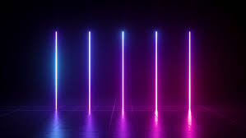Flynn’s design aesthetic is usually neon-blue and black, but it can also vary from his movie; Tron. In his movie his design colours also includes neon-orange and light-blue neon. Flynn also likes symmetrical shapes and shapes with sharp edges most of the buildings, cars, other vehicles and weapons are based around these 3 simple and basic ideas. Flynn also likes to mix neon-blue and black in his designs to make a futuristic scene, the main weapon in the game is a halo disk and it also gives a futuristic vibe because it looks like a UFO. There are two main teams in the movie; the blue the orange. The blue is the protagonist; the good guy, the orange is the antagonist; the bad guy. The antagonist; orange Flynn, also likes the idea of controlling AIs in the game/movie. Flynn’s aesthetic is also based around very vibrant colours aside from neon blue and orange, his arcade also has colours like pink, yellow and red. Flynn is also really into symmetrical shapes, most of his vehicles, buildings and tournaments in the movie and game are mostly symmetrical. He also likes sharp edges because it gives an unfinished and violent texture.

## Research on data communications and its implications for web design

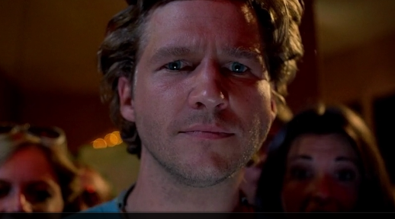Kevin Flynn

Kevin Flynn was a gifted computer programmer who, in 1982, created some best-selling video games for [ENCOM](https://tron.fandom.com/wiki/ENCOM) which included [Space Paranoids](https://tron.fandom.com/wiki/Space_Paranoids), [Matrix Blaster](https://tron.fandom.com/wiki/Matrix_Blaster), [Vice Squad](https://tron.fandom.com/wiki/Vice_Squad), and [Light Cycles](https://tron.fandom.com/wiki/Light_Cycles_(game)). Flynn's hometown is Paramus, New Jersey, where he was born in 1949. Flynn got his doctorate from Caltech in 1980 and was recruited by ENCOM shortly afterwards. One of his fellow coders/employees, [Ed Dillinger](https://tron.fandom.com/wiki/Ed_Dillinger), stole his code and presented as his own, when Flynn tried to claim it as his own he got fired for lying. In 1982 Kevin married Jordan canas and gave birth to their son, Sam. However Jordan died two years later in a car accident. In 1998 when Flynn was about to discover a gaming breakthrough, he had a peculiar disappearance. Sam, later in 2010 found out about his dads breakthrough and tried to access it, the game was Tron. After Sam’s parents had disappeared, he was raised by his mother’s parents in their place. Kevin had also coded the most important villain I the series, clu, clu was first coded to hack into ecm to prove it was Flynn’s idea. But Clu was derezed soon after. Although Flynn went into hiding he was revealed when his son came into the game, he was forced to reveal himself to Clu2. When Sam, Quorra and him were about to escape Kevin sacrificed himself for their escape.

[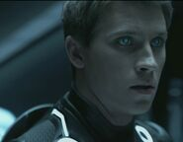](https://tron.fandom.com/wiki/File:Disc_Sinc.jpg)Sam Flynn

Sam Flynn was the child of Jordan Canas and Kevin Flynn, he was born on 1983 after his parents fell in love in 1982. Sam was a lucky child to be born to Kevin and Jordan but tragedy strikes his mother when she died in a car accident in 1985. A few years later his dad also disappeared mysteriously. It was later in 2010 Sam discovered that his father’s coworker, Ed Dilinger, stole his father’s new idea and claimed it as his own. In 2010 Sam broke into ENCOMN and leaked his father’s stolen files. Sam tried to escape but was later captured by the police, after getting bailed out Sam went exploring to his father’s arcade’s basement. He later leant Kevin left some codes in the basement’s walls. Sam figured out the codes and typed them in the computer. Sam later woke up in an unknown land with futuristic buildings and objects around him. He was later faced by 4 sirens who dressed him up, gave him armor and his light disc.

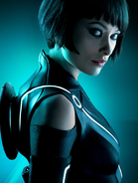Quorra

Quorra is the first apprentice of Kevin Flynn and is the breakthrough code. She first made her appearance in Tron: legacy when she saved Sam from the Clu. Quorra is a skilled and talented ISO (programs that evolve and adapt to the game’s changes). Quorra is the last remaining program of her kind because they were hunted by Clu. Quorra had a friend, Ada, but they was killed by CLU. Quorra also played a big role in saving Flynn t get back to the real world. Although she was willing to sacrifice herself for Kevin and Sam, she didn’t get to prove it as Kevin stole the chance from her for her own good and Sam’s

Kevin Flynn likes neon-blue, neon-orange and black, so the design for his website should revolve around these three colours. HE also likes symmetrical and sharp shapes. Flynn is also a fan of 3d and futuristic designs, most of his tournaments and buildings are 3D, transparent and futuristic. Using this knowledge making a website for Flynn should be fairly easy because he has multiple examples of objects, colours and aesthetic for the website.

# Design sketch

I personally like this design because it has colours from Flynn’s colour pallet and other attractive colours to attract the viewers’ attention. It is also a good website because it give the viewer a multiple choice in choosing the game and prices comparison. Making a website is also better because it is accessible for anyone with internet access. The green and white in the middle is really good spot for premium features because it is like an ad on your website about your website. It is also eye-catching and mesmerizing to look at the natural colours. The bar at the bottom gives access to our viewers and customers about contacting us. The advertisement at the top tells our customers that our deals are at the lowest price and tell them there is new arrivals in store, it also tells them what bundles are available at the moment.

# 

# Final concept design

I chose this as my final logo because it attracts the viewers’ attention straight onto the text. It is also a really good logo because it has Flynn’s main colours, blue, black and purple. It is also a really nice logo because it looks good to the viewers’ eyes. The cool blue and purple are cold colours are nice to look at.

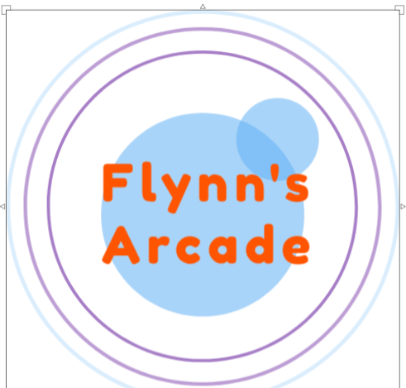

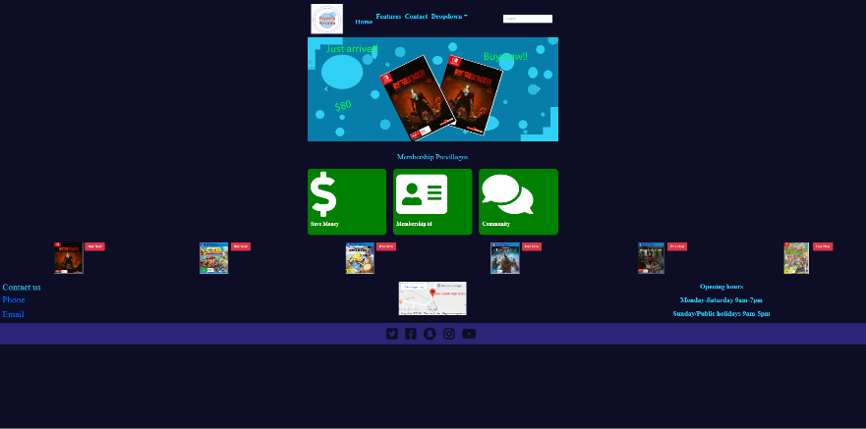I added more detail to the things at the bottom because it is attractive to look at. The dark background makes the intention sales and products pop out. The slider at the top also shows cheap bundles sand new arrivals. Ahmad said: “I like the logo because it pops out from the mainframe and is good to look at.

# design changes

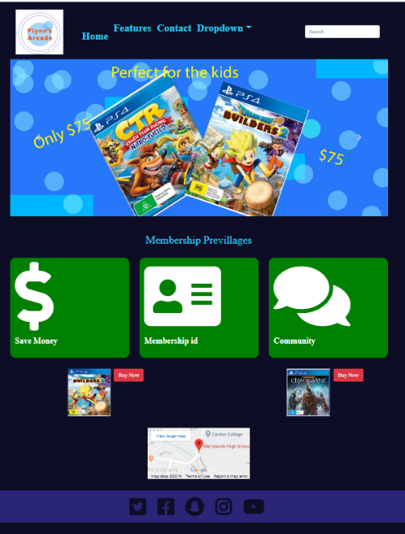



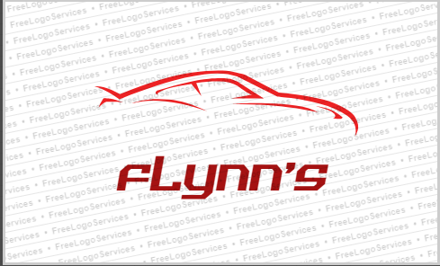

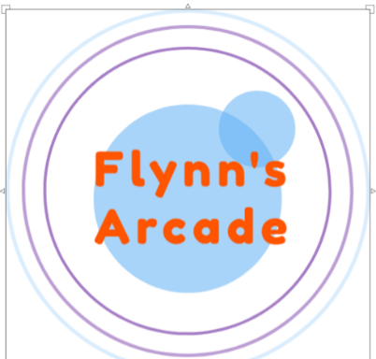

I changed the layout of the website because the old one was really bland and irritating to look at. THE new one provides a whole bunch of different features likes multiple games, it will help Flynn sell more copies of the game. Contact features, It will help the customers report issues if they are having difficulties. The new layout also shows the viewer more of the website and helps the viewer understand more of what ­­­­­­­­the website offers. The neo blue attracts the audience immediate attention because the dark background makes it pop out, thus the customers will know immediately if they have any problems the know who to contact.

The first design is too bland and does not have any co­­lours from the colour pallet, however I fixed it by making it bluer and adding extra circles around it to make it look like it’s fading out.

# Evaluation

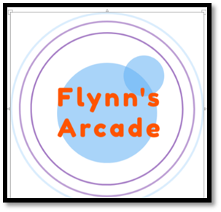The main thing I liked about my process through the subject was my website and mood board was the colours. The blue and black really suited my type of colours and aesthetics. Even though I had lots of time at my demand I wasn’t really in the mood for making up more complicated website designs, I was really lazy with my work and I could’ve done a better job. If I was more focused on my website than my colours pallet and matching colours I would’ve don’t a much better job and could’ve made a more complicated looking website. I also liked the community and premium features, if I had features coded onto them then it would have been much better. It can give access to our staffs from customers anytime, anywhere. The most important thing about my website was the sliders, the sliders took most of my time and took up half of the website. It was really challenging to create because I had to make it from scratch, but the hard work paid off because it was rally eye-catching and can be used as an advertisement tool.



The bright colours n the middle are really eye-catching and alluring to young people because of the natural and calming colours. Young people, Flynn’s main audience, will really like colours such as white, neon-blue and green because they are calming, futuristic and cold colours. I have used this technique to attract Flynn’s to be customers, If this website had promotions from popular brands and celebrities, it will get popular fast. Although celebrity endorsement is expensive, it is worth it for what to come. I can make the website much better by making it part of the World Wide Web.

# bibliography

<https://www.wpbeginner.com/beginners-guide/how-to-choose-the-best-website-builder/>

<https://www.websitebuilderexpert.com/website-builders/wix/wix-review/>

<https://tron.fandom.com/wiki/Flynn's_Arcade>

<https://tron.fandom.com/wiki/Sam_Flynn>

<https://tron.fandom.com/wiki/Kevin_Flynn>